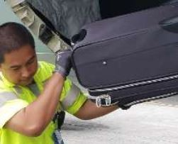
Is Hiring Ramp Agents at SEATAC
Why people like it here:
At McGee, you will earn a competitive wage and benefits; have the opportunity to grow and the freedom to try new ideas. Our team members like the company diversity, schedule flexibility and travel privileges. Your experience is valued and every day is different. If you like learning new things, take pride in the work that you do and being part of a team you will like it at McGee Air Services.
Details:
- $16.54/hour
- Health Care Benefits
- Flight privileges after 30 days
- Bonus Incentives
Must meet listed job qualifications below:
- Must be at least 18 years old
- Authorization to work in the U.S. (US Citizen or legal work status)
- Able to speak, read and write English
- Able to accept full time employment (including nights, weekends, holidays)
- Valid driver's license required
- Ability to lift up to 75 pounds frequently
- Ability to understand and interpret flight schedules and airline flight destination information
- Must pass drug screen and background check
- Regular and predictable attendance
- Able to obtain airport security clearance, customs seal, and USPS security clearance
- 5 consecutive years residency in US or territories - USPS requirement

Apply:
• Need mor information? Apply here:
https://mcgeeairservices.applicantpro.com/jobs/

