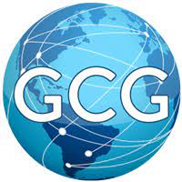
Global Concessions Group is hiring for their cigar kiosk at SEA Airport!

About Global Concessions Group:
Located inside SEA Airport, Global Concessions Group is a specialty retail kiosk selling primarily premium cigars, CBD products and men’s accessories.

Positions:
- Retail Sales Associate -- $16.57/hr - $17/hr
  - Must be at least 18 years of age
  - Knowledge of cigars is preferred
  - Ability to speak, read and write English fluently
  - Minimum of one-year sales experience
  - Must be customer service oriented and well organized
  - Must pass TSA background check and fingerprinting

Apply Today:
- Email your resume and cover letter to info@globalconcessionsgroup.com
- View their Facebook page to view products sold at the kiosk: https://www.facebook.com/GCGCigarkioskorlando

** Airport Jobs is a program of Port Jobs. Port Jobs is not the hiring employer for this event. Port Jobs is not responsible for the actions of the hiring employer. **

